Notebook 1: How to Initialize a Node.js Project

Node.js is an app you can get that helps you run servers.

# Requirements

* Access to command prompt and file explorer

# Creating a project folder

Creating a project folder is a useful thing to do when you need to. Helps keep everything organized, but more importantly, you need one to initialize a node.js project effectively.

1. Open file explorer and right-click an empty space.
2. “new” “folder”. This’ll create a blank folder. Rename the folder to whatever, but for this, I’m just going to call it ‘Testing’ to simplify things.

# Using ‘npm init’

* Copy the file path, then open command prompt.

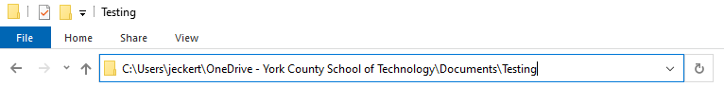

copy this with ctrl + c, then open up command prompt.

With command prompt open, write ‘cd (paste the file path)’

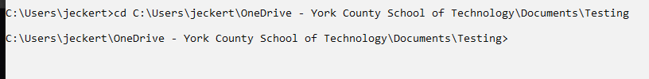

1. When you’re in the folder, use the command ‘npm init’, then ‘npm I’
   1. (don’t forget to go to the node website and install the version you need)
2. Input the information it asks as you see fit. You can spam enter, but I highly recommend taking the time to fill in the information.
3. When you open the folder, you should see something inside. That means it worked.

# Making the main .js file

1. If you clicked out of the folder, go back into it.
2. Right click an empty space in the folder, select ‘new’ ‘text document’
3. Replace the .txt at the end with .js. Name the document anything you want to.

* **If you don’t see the .txt, you don’t have file extensions on. At the top of your File Explorer, select ‘view’ then ‘File name extensions’.**
* When it’s all done, you can run the application through Command Prompt. **To do so:**
* Enter the folder with the .js file
* Enter the command ‘node (whatever you named the file).js’